

|  |
| --- |
| 181*/*2 |

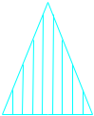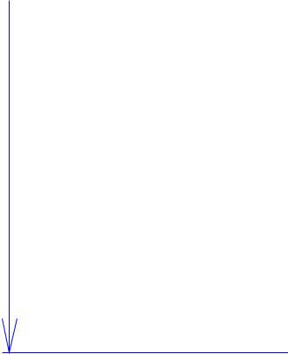

Structural Design



(Inside View)

**Vertical corrugation**

Design#:

**130331-02_A**

Customer:

**DeMet's Candy**

Description:

**divider support - 5oz Flips qtr plt**

54

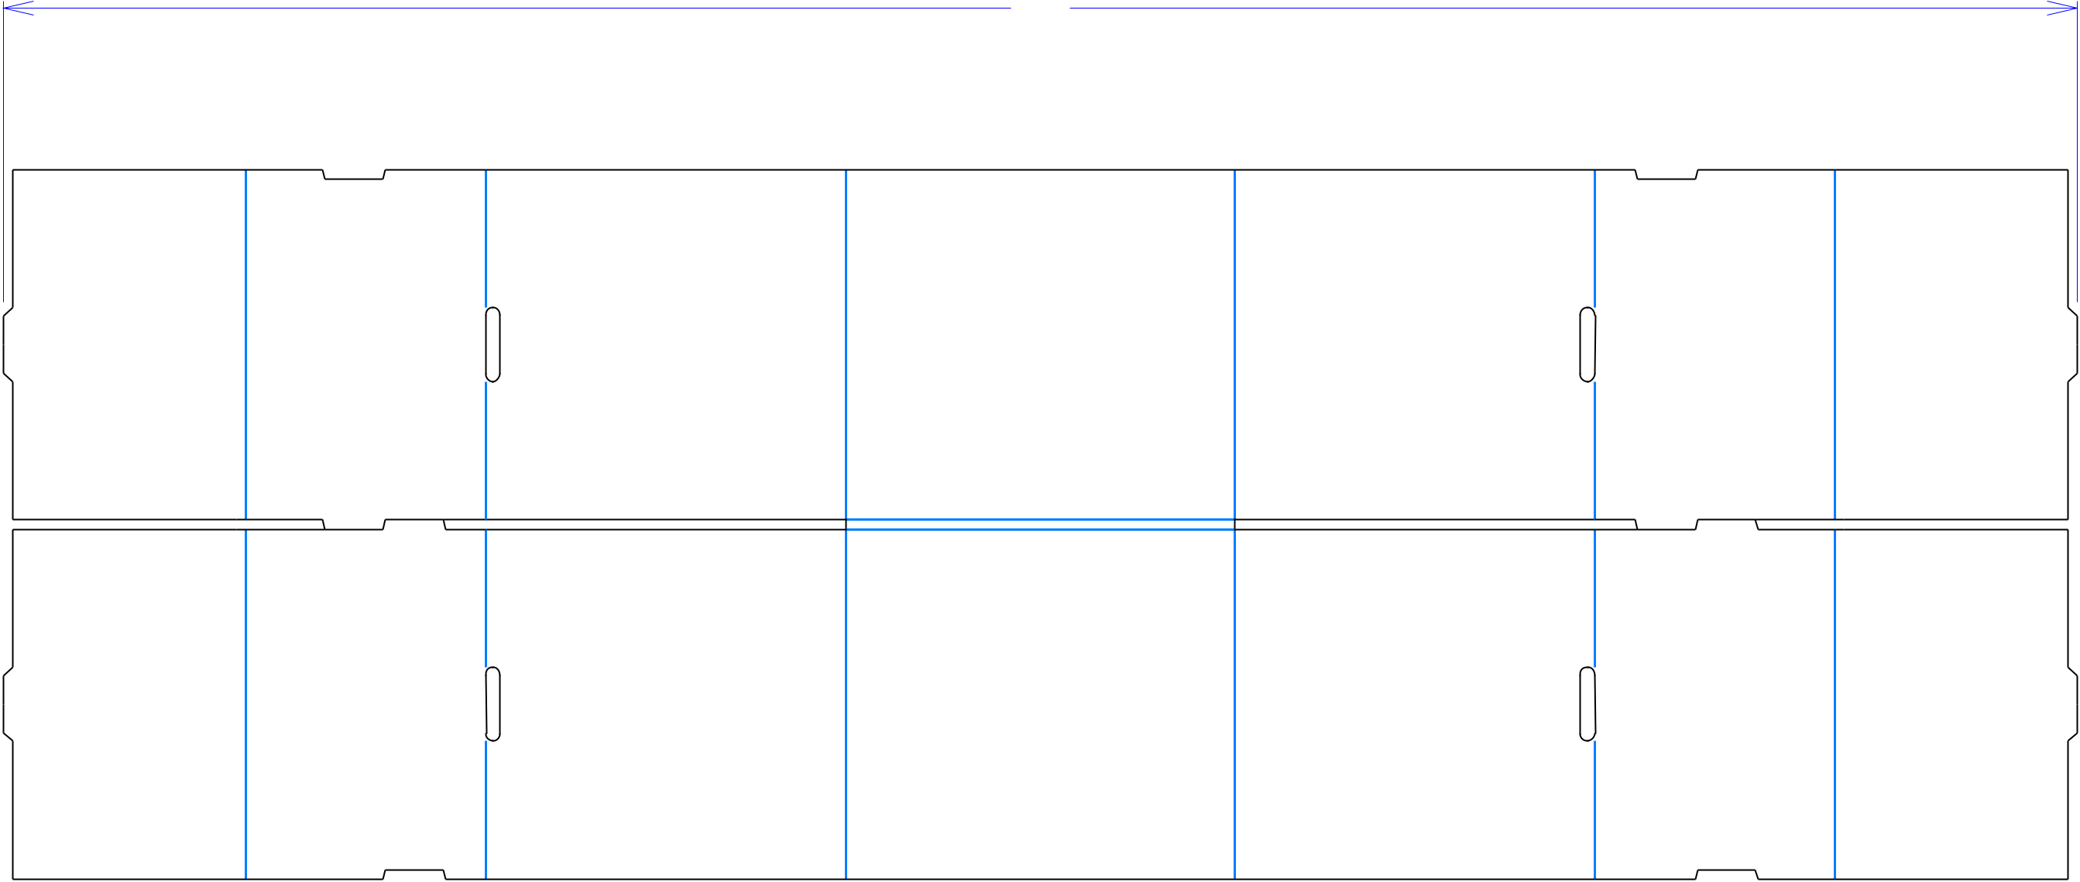

**SINGLE-OUT DRAWING**

Qty/Unit: **4**

Style: **NJDC**

Board: **40CK**

Combination: **35HP - 36M - 35HP**

I.D. : **23+3/8 x 19+3/8 x 9+1/8**

Area of Blank - Waste : **6.79 sq. ft.**

Waste on Blank : **2.12%**

Finished Piece Weight: **0.84 lbs./382.95g**

Over-all Blank: **18+1/2 x 54**

**D/C From Label Side**

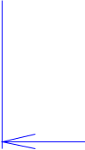 61*/*16 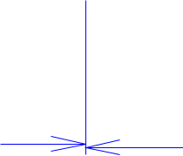 61*/*4 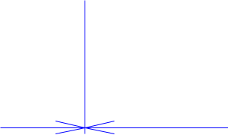 93*/*8 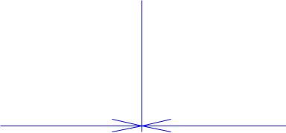 101*/*8 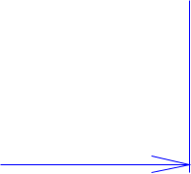

Notes:

**NOTE: DIE CUTTING CREW - DIE CUT**

**FROM OUTSIDE**

Revision Info: **[A] 08/27/2013**

**Revise Fold Over Locks to Single Score**

Designer: **Alan Groff**

Cut Crease Crease with Matrix Cut Crease Half Knife Cut Tear Tape Perforation



Designright and Copyright of DS Smith Corrugated Packaging Ltd. This technical Specification is subject to Manufacturing tolerances. Drawing dimensions shown are crease to crease. Date printed: 05/03/2019